FOOD MANAGEMENT SYSTEM

Use-Case Specification: Display purchase orders

Version <1.0>

Revision History

|  |  |  |  |
| --- | --- | --- | --- |
| **Date** | **Version** | **Description** | **Author** |
| <7/12/2020> | <1.0> | <details> | <Nguyen Thu Trang> |

Table of Contents

1. Use-Case Name 4

1.1 Brief Description 4

2. Flow of Events 4

2.1 Basic flow 4

2.2 Alternative flow 4

2.2.1 <First Alternative flow> 4

2.2.1 <Second Alternative flow> 4

3. Special Requirement 5

3.1 <First Special Requirement> 5

4. Preconditions 5

4.1 <Precondition One> 5

5. Posstcondition 5

5.1 <Postcondition One> 5

6. Extension Points 5

6.1 < Name of Extension Points> 5

Use-Case Specification: Display purchase order

1. **Use-Case name**
   1. **Brief Description**

This use case defines the view of purchase orders. The system allows Admin view the orders that customer has been ordered

* 1. **Actor**

Admin, customer

1. **Flow of Events**
   1. **Basic Flow**

First, admin login the system, click on view of product and then on View purchase orders on the main interface. The system display information of the order.

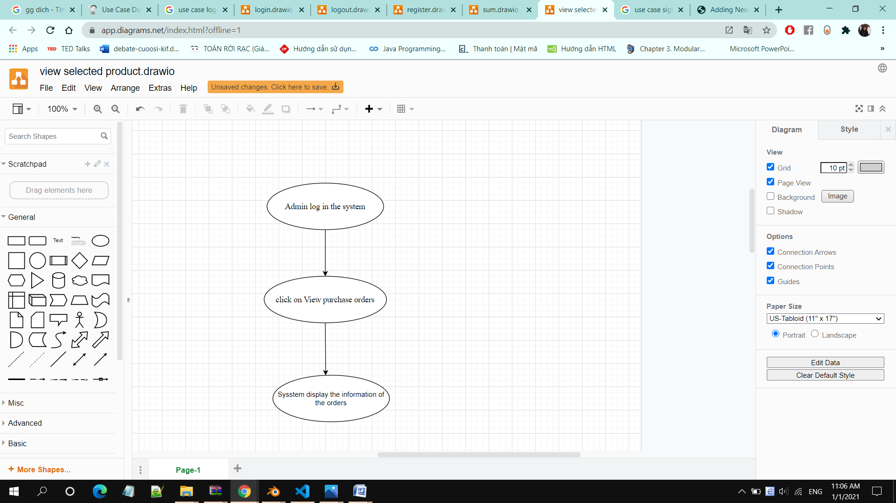

1. **Special Requirements**

Admin must know how to use the product management system.

1. **Preconditions**

Admin has successfully logged in

1. **Postconditions**

Admin returns to the main interface

Admin can see the orders

1. **Extension Points**

No extension points.